Assignment 4:

Perform Health Checks and Remedy Issues

Step 1: Conduct a health check on your test environment

Incident Report

Ticket Number: INC-00339

Client Name: [Brenda Brown]

Date: [11/10/2024]

Summary: Low Disk Space Warning on Host sobanoropsf

SLA TYPE: LEVEL 2 (Basic)

Number affected users: 1

Description of the Issue:

This incident has been raised due to a WARNING status reported by the Nagios monitoring system for the host sobanoropsf. The warning indicates that the disk space on the primary hard drive is critically low, which could lead to operational issues if not addressed promptly.

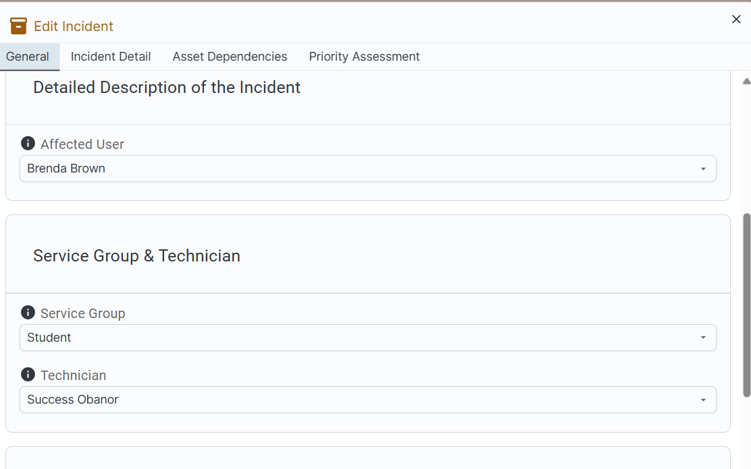

Step 2: Create your change request to remedy this issue

Change Request

Ticket Number: CHR-00020

Requested By: [Success Obanor]

Date: [11/10/2024]

Summary: Adjustment of Disk Monitoring Thresholds in Nagios

Change Request Type: Normal

Number affected users: 1

Install Description:

The change involves updating the disk space monitoring thresholds in Nagios for host sobanoropsf. The process includes:

* Accessing the Nagios server configuration files.
* Modifying the disk.cfg file to lower the warning threshold from 73% to 15%, and the critical threshold from 72% to 10%.
* Modify the localhost disk partition warning threshold to 20% and critical threshold to 10%.
* Saving the changes and restarting the Nagios service to apply the new configuration (if needed).
* Verifying that the new thresholds are reflected in the service checks.
* The installation process is straightforward, expected to take approximately 10-15 minutes, with minimal disruption since it does not involve any system downtime or service interruptions.

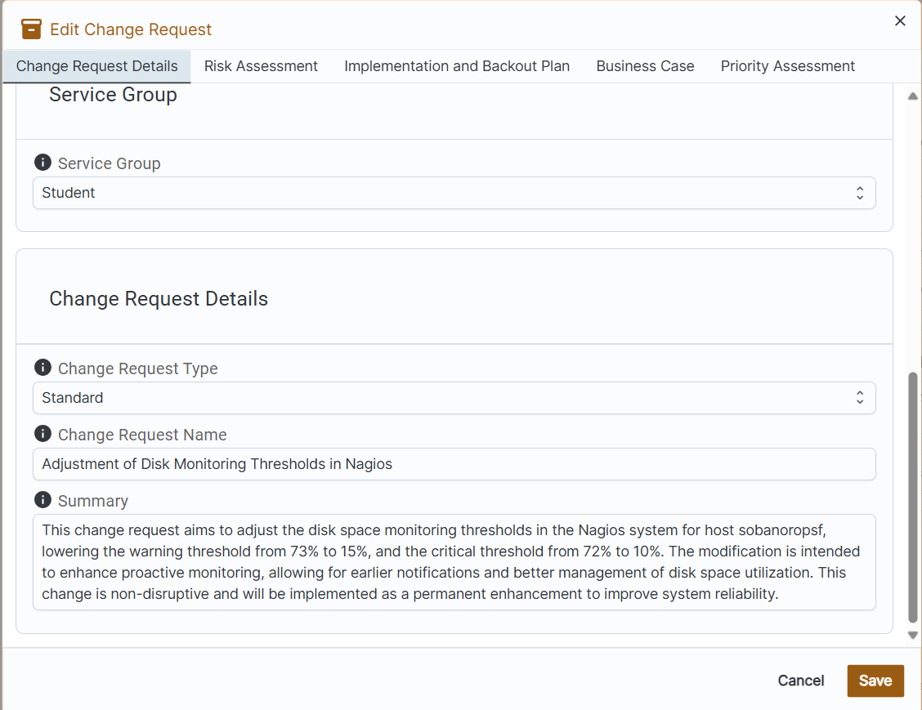

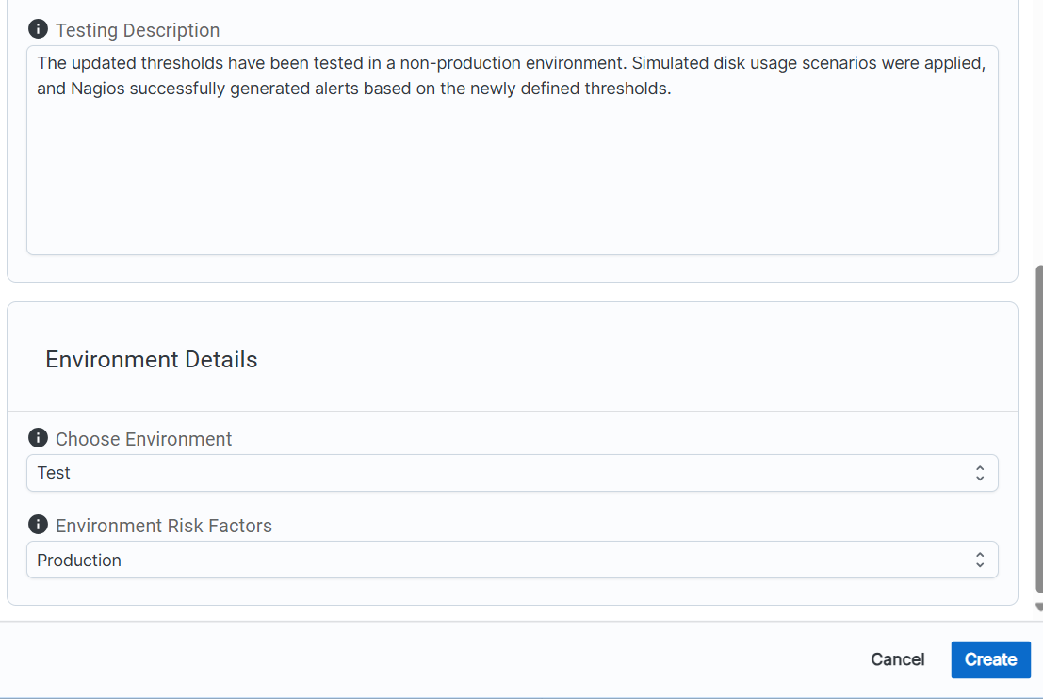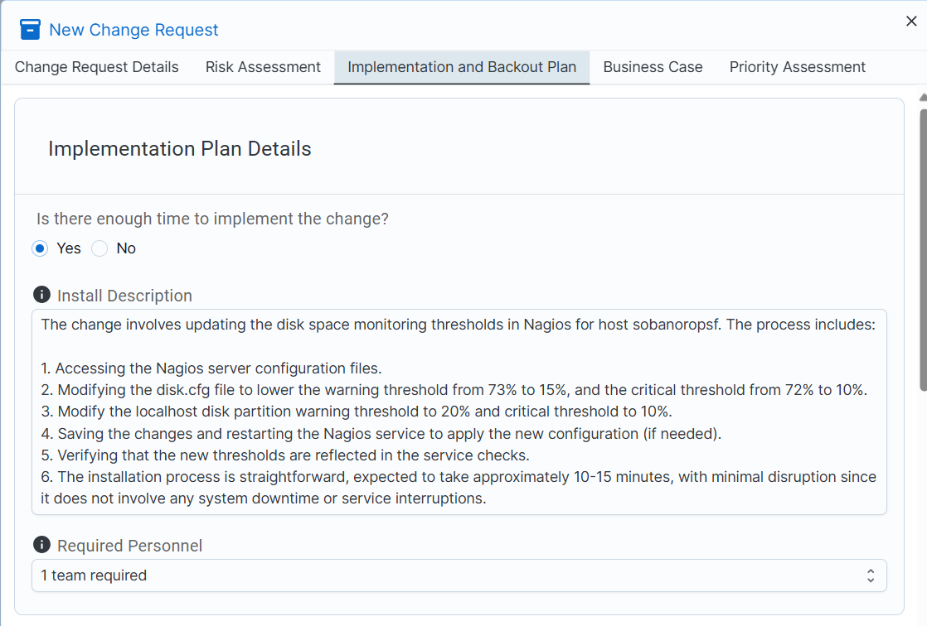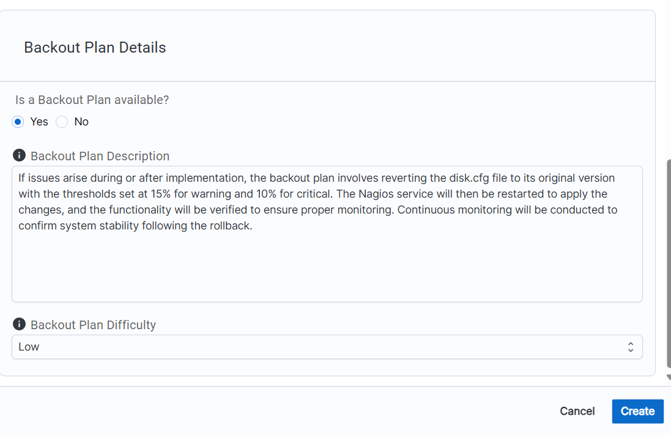

Step 3: Create a communication on the results of your health check to report  
to your IT Ops Supervisor (Your Instructor). Your communication should  
include the timing and date of your health check, and the results of the  
check. Any remediation that was required and the steps you took to do so.

Health Check Report for Nagios Monitoring System

To: Michael Arnold (Instructor)

From: Success Obanor

Date: October 12, 2024

Subject: Health Check Report on Disk Monitoring on Host sobanoropsf

Health Check Timing

Date of Health Check: October 12, 2024

Time: 20:52:19

Health Check Results

During the health check on the Nagios monitoring system, I reviewed the disk usage status for the host sobanoropsf. The system reported:

Service: Hard disk

Status: OK

Free Disk Space: 28,312 MiB (73.59%)

Performance Data: /=10160MiB;34479;36507;0;40564

The monitoring thresholds were appropriately set to trigger a warning at 15% and a critical alert at 10%. The health check confirmed that the system is functioning properly, with disk usage well within safe operating limits.

Remediation Steps

During the initial setup, I noticed the disk space thresholds required fine-tuning to ensure timely alerts. I took the following steps:

Threshold Adjustment:

* I updated the disk.cfg configuration file in Nagios, lowering the warning threshold from 73% to 15%, while the critical threshold from 72% to 10%.
* Verification:
* After the configuration update, I restarted the Nagios monitoring service and verified that the changes were applied correctly.
* Post-Change Monitoring:
* I monitored the system for any unusual behavior or alerts post-change. The system has been running in a healthy state since the update, with no issues reported.
* Confirmation of Problem Resolution
* The post-change health check confirmed that the disk monitoring service is functioning correctly, and that the previous configuration issue has been resolved. The system is now better configured to provide early alerts for disk space utilization, improving overall monitoring efficiency.

Should you require any further information or clarification, please feel free to reach out.

Best regards,

Success Obanor,

IT Operations Specialist.